

Assignment 3
  - Tower Of Hanoi

https://github.com/mmujtaba25/CS-110

Muhammad Mujtaba
CMD ID: 540040
mmujtaba.bese25seecs@seecs.edu.pk

  - Class: BESE 16B
  - Batch: 2k25
Table of Contents
Overview of requirements 3
Source Code: 3
Trace: 3
Screenshots of program output: 3
Trace document (Annex-I): 4
Function Calls for N disks ($\text{2}\text{N} \text{- 1}$ calls): 4
Function Calls for 3 disks (7 calls): 4
Function Calls for 5 disks (31 calls): 5
Source code (Annex-II): 6

Overview of requirements

Source Code:
A working example of Tower of Hanoi, that prints the move sequence to solve the game. The program should work for 5 disks. The program should be done recursively.
Source Code Requirements:
- Implementation of Function:
void hanoi(int n, char from, char to, char aux);

Trace:
A detailed trace of the recursive calls showing the order in which calls are made and completed.

Screenshots of program output:
For 5 Disks
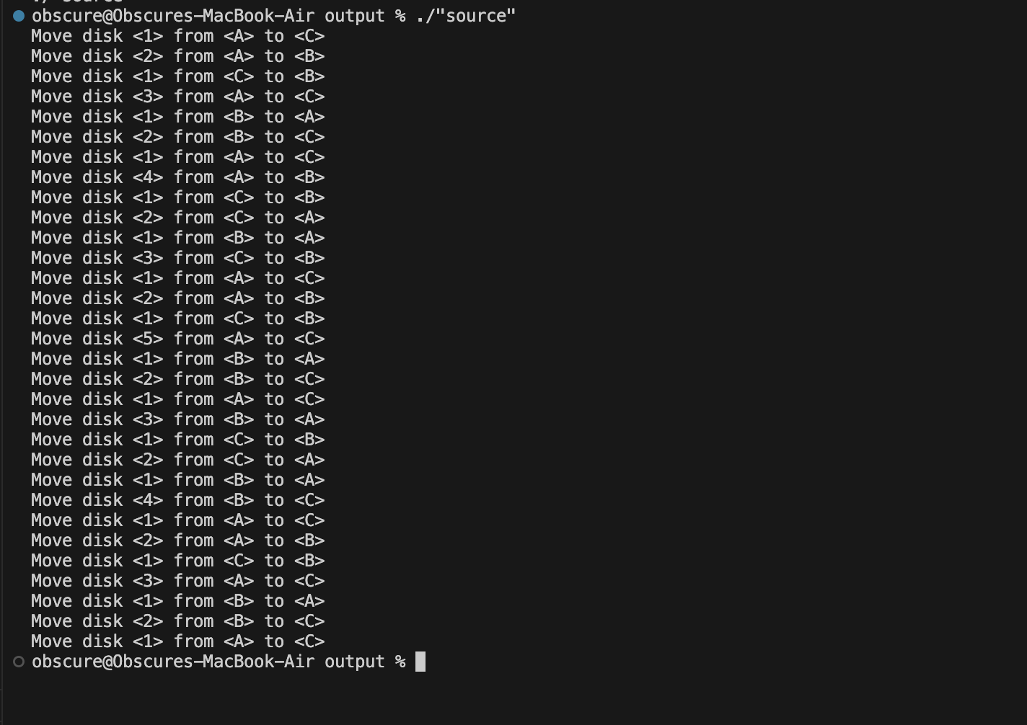
For 3 Disks
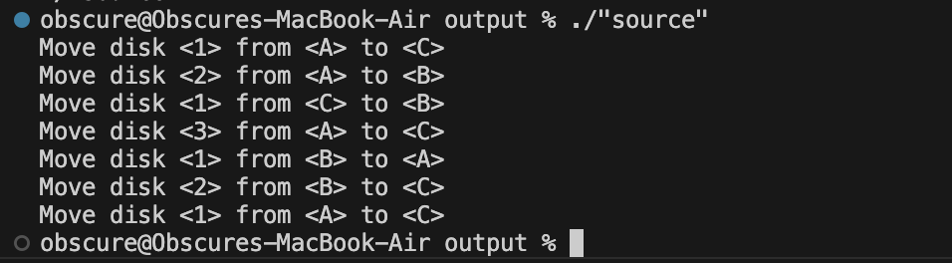

Trace document (Annex-I):

Function Calls for N disks (${\text{2}}^{\text{N}} \text{-} \text{1}$ calls):
hanoi(N, from, to, aux);

calls
hanoi(N - 1, from, aux, to);
moveDisk(N, from, to);
hanoi(N - 1, aux, to, from);

Function Calls for 3 disks (7 calls):

Function Calls for 5 disks (31 calls):

Source code (Annex-II):
#include <iostream>

inline void moveDisk(int disk, char from, char to)
{
std::cout << "Move disk <" << disk << "> from <" << from << "> to <" << to << ">\n";
}

void hanoi(int n, char from, char to, char aux);

int main()
{
constexpr int NUM_DISKS = 5;
hanoi(NUM_DISKS, 'A', 'C', 'B');
return 0;
}

void hanoi(int n, char from, char to, char aux)
{
// base case; move one disk
if (n == 1)
{
moveDisk(1, from, to);
return;
}

// move (n - 1) disks from (from) to (aux)
hanoi(n - 1, from, aux, to);
// now the remaining disk in (from) is biggest one
// move biggest disk from (form) to (to)
moveDisk(n, from, to);
// move (n - 1) disks from (aux) to (to)
hanoi(n - 1, aux, to, from);
}

